**MPU 2242**

**Individual Assignment 1**

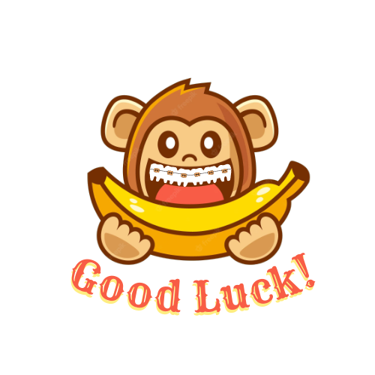**Logo**

First of all, the main object of this whole logo is a monkey who wears braces and loves to eat bananas. This is me in reality.

Why did I choose monkey? This is because I was born in 2004. Among the 12 Chinese zodiac signs, those born in 2004 belong to the monkey. The color of the monkey is also brownish, so I used the original skin color of the monkey. Then, I have braces now, so I am collectively called braces girl. Why am I so impressive? Because I change the color of my braces every time, my friends will ask, what color did you change this time? I will find it very funny. In addition, monkeys like to eat bananas, and I am no exception. As long as my mother buys bananas, I can eat 2 bananas a day. In the end, the mantra I gave myself is good luck, because every time I hear people around me share something, I will say good luck. This represents a small blessing from me, and I hope everything goes well for them. I put the word "good luck" in orange-red because it is the New Year, and orange-red represents “ONG”, which means that our lives will be very lucky throughout the year.